26-8-2026

1. PROLOG PROGRAM TO SUM INTEGERS FROM 1 TO N

Aim
To write a Prolog program to calculate the sum of integers from 1 to N using recursion.

Algorithm
- Define a predicate sum_to_n(N, Sum).
- If N = 0, the sum is 0.
- Otherwise, recursively calculate the sum up to N-1.
- Add N to the recursive result.
- Display the final sum.

Program
sum_to_n(0, 0).

sum_to_n(N, Sum) :-
N > 0,
N1 is N - 1,
sum_to_n(N1, S1),
Sum is N + S1.

Output
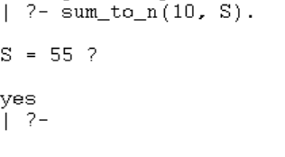

Result
Thus, the Prolog program to calculate the sum of integers from 1 to N was successfully executed.

